SEG Awards Level 2

Motor Vehicle Studies

Underpinning Knowledge Evidence Record

F/601/5563 Knowledge of Motorcycle Preparation and Inspection

Learners Name
SEG Awards Registration Number
Centre Name
Assessor 1 Name
Assessor 2 Name

DECLARATION OF AUTHENTICITY

This declaration must be completed and signed by the learner and countersigned by the tutor / assessor and covers all evidence submitted for moderation.

Learner Name
Unique Learner Number (ULN) |  | SEG  Learner Reg. ID
Qualification Title
Centre Name

Learner statement of authenticity

Before signing please read the guidance below.

I confirm, that the attached assignment / portfolio is all my own work and does not include any work completed by anyone other than myself. I have completed the assignment / portfolio in accordance with SEG Awards’ instructions and within the time limits set by my centre.

Signature |  | Date

Centre confirmation of authenticity

On behalf of …………………………………….(insert centre name), I confirm that the above mentioned learner, to the best of my knowledge, is the sole author of the completed assignment / portfolio attached, and the assessments have been completed under the required conditions.

Signed |  | Date
Name
Title

Guidance for Learners

You have been asked to sign this Declaration of Authenticity and place it at the front of your portfolio or course work assessment. It confirms that the work you have submitted for assessment is your own and that you have not copied it from someone else or allowed another learner to copy it from you.

When preparing any course work it is good practice to undertake research using information from published sources. If you quote directly from these sources then this must be indicated in your work by using quotation marks and referencing the document from which the quotation was taken. You must then comment in your own words on any ideas expressed.

Assessors, internal verifiers and SEG Awards’ external moderators and verifiers are subject specialists who can spot the use of published materials that may be passed as your own words or ideas.
If you do copy words from a published source and do not indicate their reference you will be committing plagiarism. This is considered a form of cheating and may result in your assessment being declared void.

Contents

Task No | Title | Assessment Criteria
1 | Preparation and inspection | 1.1, 1.2, 1.3, 1.4, 1.5, 1.7, 1.10
2 | Inspection methods | 1.1, 1.2, 1.3, 1.4, 1.5, 1.6, 1.7, 1.8, 1.9

Task 1 – Preparation and inspection | Assessment Criteria 1.1, 1.2, 1.3, 1.4, 1.5, 1.7, 1.10

Motorcycle Details | Motorcycle Condition Report
Make___________________________  Model__________________________  Registration/VIN No.____________________________  Colour__________________________ | 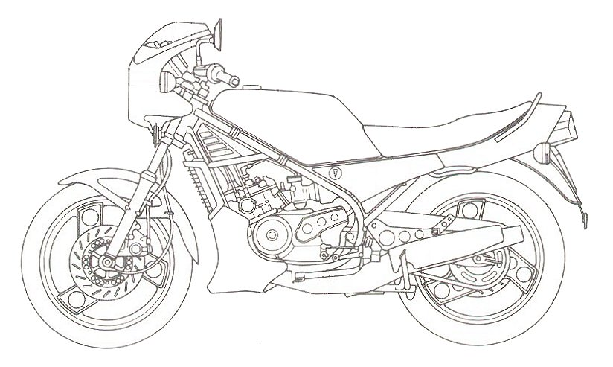
Identify systems to be inspected using different inspection methods | Inspection Methods
 | Pre Service | Post-repair | (PDI) Pre-Delivery  Inspection | MOT
Explain the differences between different motorcycle inspection methods

Task 2 – Inspection methods | Assessment Criteria 1.1, 1.2, 1.3, 1.4, 1.5, 1.6, 1.7, 1.8, 1.9

Identify the inspection method against motorcycle specification and legal requirements  (at least 3 of the 4 methods must be covered) | Pre Service | Post-repair | (PDI) Pre-Delivery  Inspection | MOT

Engine
Component | Method of inspection
Chassis/frame (steering, suspension, brakes, wheels and tyres)
Component | Method of inspection
Transmission and driveline
Component | Method of inspection
Electrical and electronic
Component | Method of inspection

What are the advantages of having a motorcycle correctly inspected?
Why is it important to sign workplace documentation and motorcycle records?

Unless otherwise stated e.g. for some entry level qualifications, learners can work together but should identify sections which are their own work.

